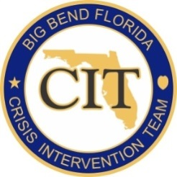

Big Bend Crisis Intervention Team Training
40- Hour Basic Course Registration

CLASS DATES (please indicate which class you are registering for):
March 27 – 31, 2023
June 12 – 16, 2023
September 18 – 22, 2023

REGISTRANT INFORMATION (email completed form to CriminalCM@leoncountyfl.gov)

After submitting this form, you will be registered for the class unless you hear back from the Coordinator. Please ensure you have permission from your agency to attend. Details regarding each class will be sent out via email, a few weeks prior to the class starting.

Multiple persons from the same agency can be registered on the same form in the spaces below. If you need additional spaces, please complete and submit an additional registration form.

NAME | AGENCY | DIVISION | EMAIL

If you have questions, please feel free to contact:

Brenda Mueller, Criminal Court Coordinator
Phone: (850) 606-4450
MuellerB@leoncountyfl.gov

